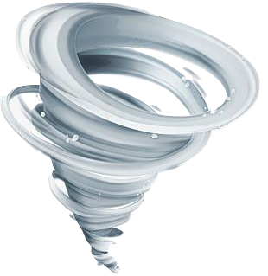

Quest: Have less than 11 stars worth of creatures on your field, reward: -6 cost.

: +1 ATK.

: +1 SPD.

Nature: +1 SPD.

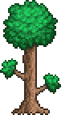

Cloud Soiree



